Rick Hartley PCB Notes
Christopher Kalitin

PCB Layer Ordering, Pouring, and Stackup
https://www.youtube.com/watch?v=52fxuRGifLU

All signals need a return path. Extremely fundamental mental model.

Electric fields are generated by all charged objects. Charge carriers regardless of where they are or what they are doing.

Magnetic fields are generated by moving charge carriers, ie. current.

Skin effect: AC current moves more on the outer edge of conductors, exponentially falling off as you move towards the center.

Coupling:

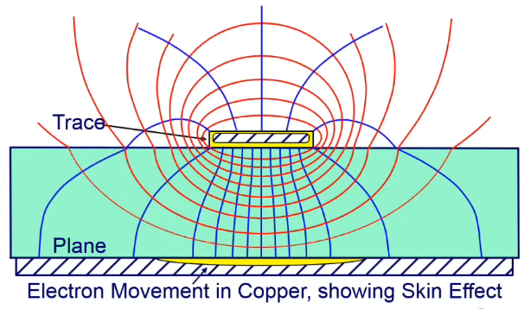

https://grok.com/c/09a7c891-cfd1-4a36-bfe1-153cdad6c736

Coupling occurs due to electromagnetic fields, defined by Maxwell’s equations.

Remember: Changing electric field sauce magnetic fields.

Electric coupling: Capacitive - Parasitic capacitance
Magnetic coupling: Inductive

Electric coupling occurs when two conductors are close enough that their E fields influence each other. Charges on one inductor induce opposite charges on the other, the operating principle of a capacitor.

Magnetic coupling induces a voltage on nearby conductors when current in a primary conductor changes.

Important:
You want electric and magnetic coupling to occur between your signals and a ground plane, not from signal to signal.

Ie. you want the red and blue lines, not pink:
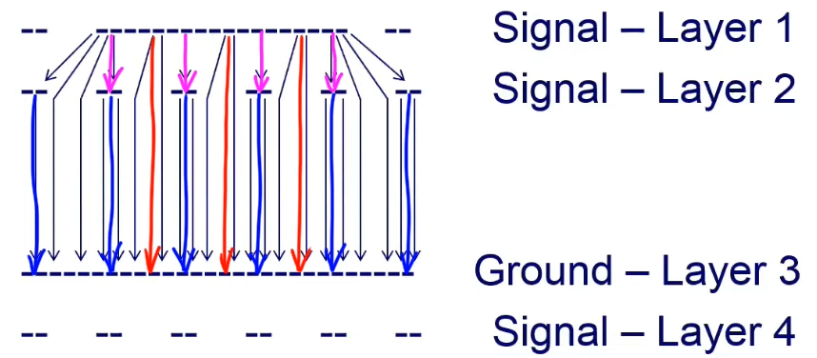

As a heuristic: treat the top and bottom layers as their own boards.

Co-planar return path: signal and ground on a single plane next to each other.

Ie. route ground traces in between signal traces:
- You should also have via’s connecting your ground trace to a ground plane every 10th wavelength of the max harmonic frequency of the signal (ie. just add vias).
- Notice the alternating white and blue traces:
- Better yet, just make it all a ground plane (power on the lower layer then? Which is better)
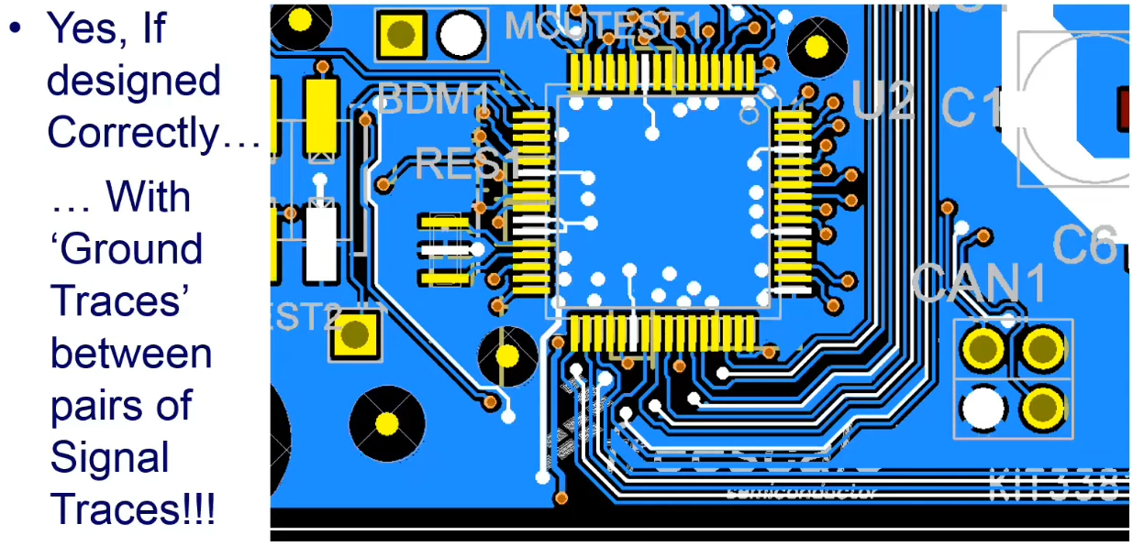

This design has a ground plane on the plane with the IC because that IC wasn’t great at containing its electric fields, coupling to the ground plane immediately.

If the rise time of your IC is eg. 500 picoseconds, you have harmonic energy in gigahertz on your board. Even if the clock is eg. 10 megahertz, that rise time is giving you gigahertz.

Be careful how you change signal layers, you always need to picture the return current path and make sure it’s very close to the signal so they’re tightly coupled, and your E fields aren’t coupling to things you don’t want them coupling to:

Note all energy is moving on the outside of the vias (skin effect I think), so what the via is filled with doesn’t matter.

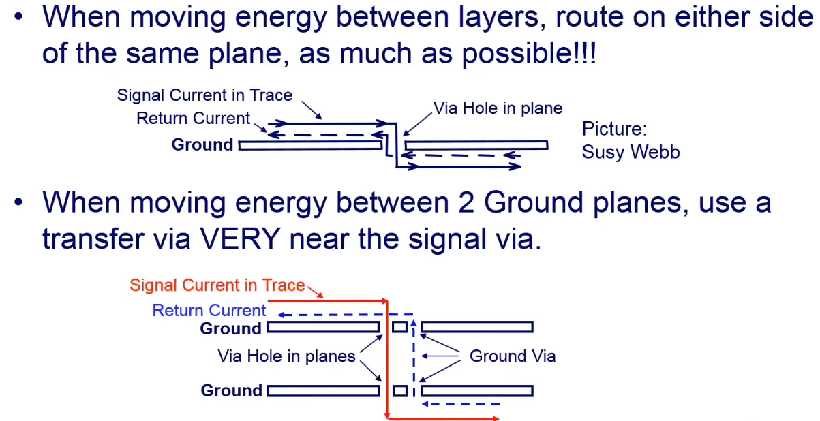
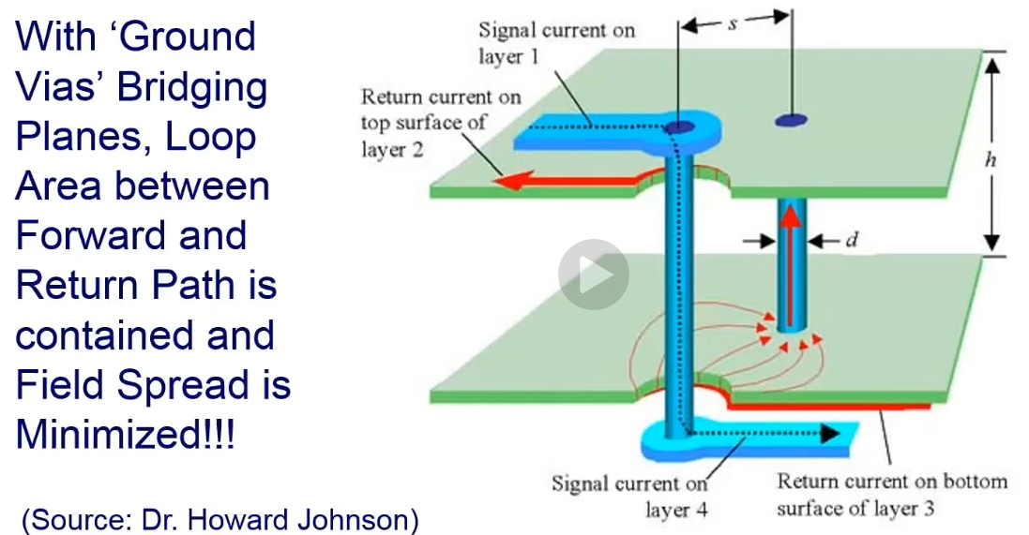

For >250 MHz, a decoupling capacitor acts as an inductor!

Note this is all for AC signals (noise, EMI):
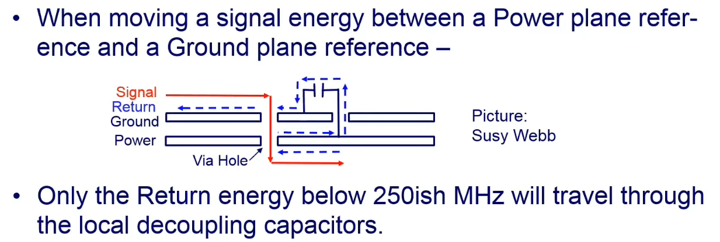

If your ground and power planes are within 8-10 mils (max) (<0.2 mm) of each other, they act as a capacitor.
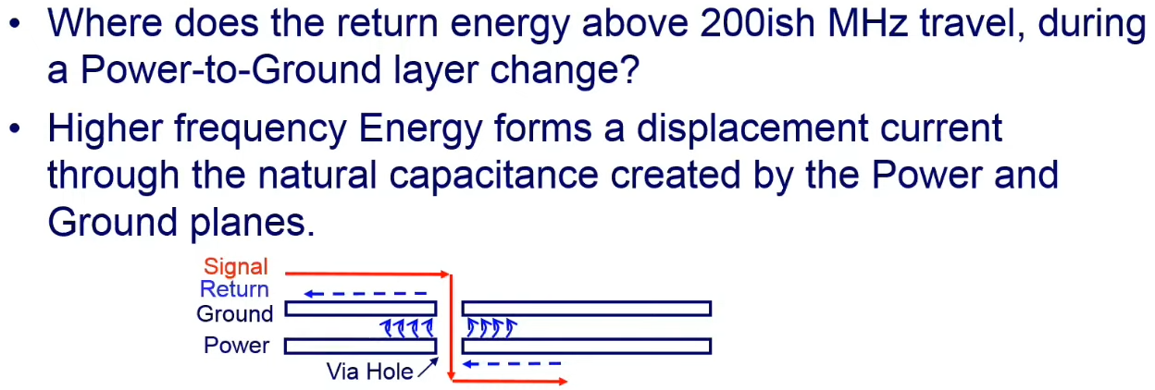

Woah! Note that the return path for a signal doesn’t necessarily have to be the ground plane(?!), you can use the power plane as well??

There are people who have to characterize noise and EMI for gigabit signals, there are technique here, you just haven’t heard of them.

If you want energy not to couple, you need to give it a reference plane (either ground or power close to ground for capacitive coupling, see above notes):
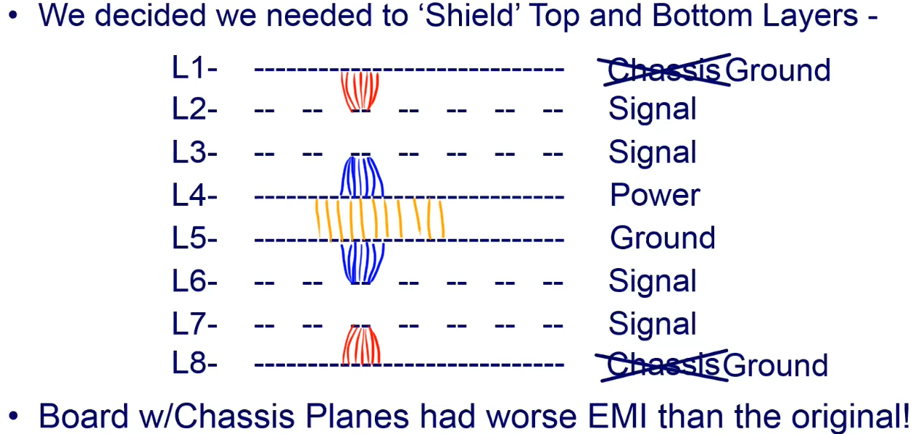

Note using chassis ground (not connected to board ground) doesn’t work because chassis ground is now trying to couple to something else, and your EMI problem gets worse. You need well defined reference planes.

You can’t just put a signal trace between a ground and power plane because the signal line will couple to both (red & blue), meanwhile the power and ground planes are coupled to each other (yellow):
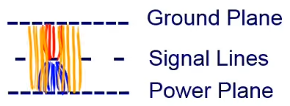

You can solve this by putting a ground plane directly next to (<0.25 mm) the power plane.
Now the power plane is coupling to the lower ground plane, and your references on both side of the signal plane are well defined and valid:
(even better, swap the bottom power and ground planes)
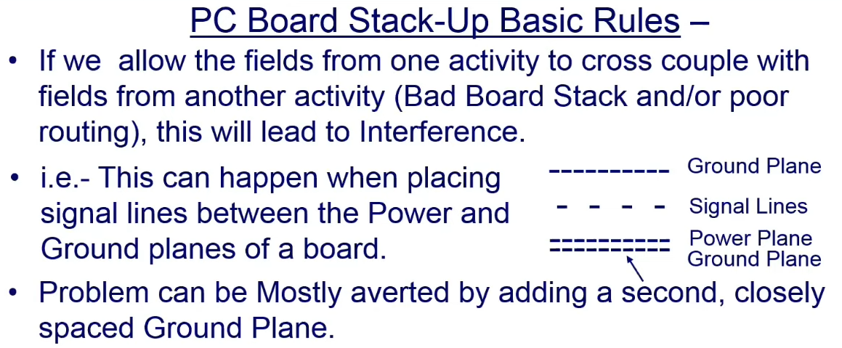

Remember: A via every 10th wavelength of the maximum frequency.

Ideally, the pours on alternating layers should alternate power/GND. This way effectively capacitance between power and ground increases, which provides a nicer return path.

Diagram of above:
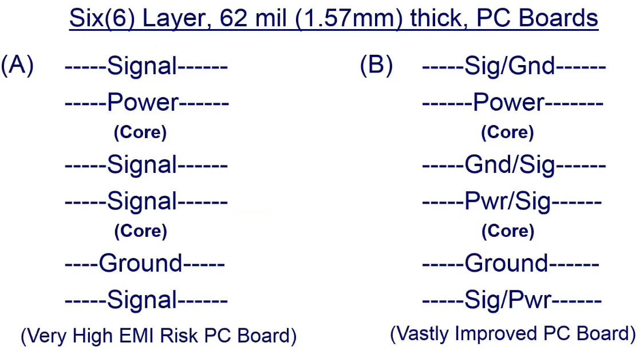

In this stackup, if you’re changing a signal from layer 1 to 3 you don’t need a ground via.
But, if changing from 1 to 5, you need a ground via. Otherwise, the common well defined reference plane is lost.
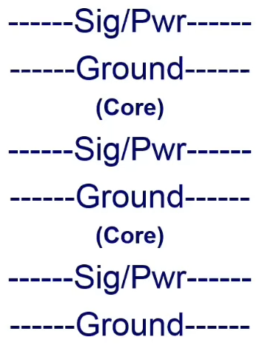

“It isn’t our job to make things easy, it’s our job to make things work.”
Are you sure? What’s embedded’s job? Ok maybe I’m sure.

For 2 layer boards with signals next to each other, give them many grounds next to each other:
Better yet, make the dielectric thinner.
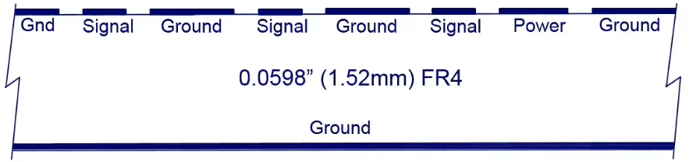

Rigid FR4 boards can’t be odd layer counts? Manufacturers charge you for even (+1) boards.

Be very careful with the shunt resistor signal. Give it lots of ground reference and shielding.

Adjacent layer power planes will couple into each other, which you don’t want. If you must, make them far from each other, thick dielectric.

You want high capacitance to ground for good coupling. Ie. more area shorter distance.

Nvm, you do just want ground around all signals. Only sometimes can you get away with power with a reference (if it’s really close to ground).

How to Achieve Proper Grounding
https://www.youtube.com/watch?v=ySuUZEjARPY

